

Submitted Through

**Department of Computer Science and Applications**

Affiliated To

**DR. VISHWANATH KARAD MIT WORLD**

**PEACE UNIVERSITY, PUNE, MAHARASTRA, INDIA**

A PROJECT REPORT

ON

**COMPILER CONSTRUCTION**

**COURSE: COS6038B - OPEN-SOURCE TECHNOLOGIES**

AS A PARTIAL REQUIREMENT FOR THE DEGREE

OF

MASTER OF COMPUTER APPLICATION

(M.C.A SCIENCE)

**_________________________________ ____________________________________**

|  |  |
| --- | --- |
| **SUBMITTED BY:** | **GUIDED BY:** |
| Varma Sonika R. [1132220233] | Prof. Dr. Anuradha Kanade, |
| Dhanani Rohan J. [1132220432] | Prof. Swapnil Goje |
|  | **Date : 1/12/2023** |



**DEPARTMENT OF**

**COMPUTER SCIENCE AND APPLICATIONS**

Certificate

This is to certify that**,** Varma Sonika and Dhanani Rohanstudentsof MCA (Science) Semester III has/have successfully / partially completed COS6038B - Mini Project on Open-source Technologies in partial fulfilment of MCA (Science) Sem III under Dr. Vishwanath Karad MIT World Peace University, for the academic year 2023-2024.

______________ ______________

Dr. Anuradha Kanade Prof. Swapnil Goje

**Internal Guide 1 Internal Guide 2**

Dr. Jalindar Gandal Dr. Rajeshree Khande

**Program Head Program Director**

Date: ___/___/______

External Examiners:

1. ____________________________ 2. ____________________________

**ACKNOWELDGEMENT**

* Our self Varma Sonika and Dhanani Rohan. Have opportunity to express our knowledge. we would like to express our gratitude to all those who gave us the possibility to complete our project.
* Success is such a comprehensive project can’t achieve single-handed. It is team effort that sails the ship to the coast. so we would like to express our sincere thanks to all the dignitaries who were involve in making this project the great joy and turning it our into successful piece of work.
* **Prof. Anuradha Kanade and Prof. Swapnil Goje** – our professor and project co-ordinates has been very prudent to us threw out the collage studies. They are the person who has giving this direction to our work and the shape to our imagination. we express our regard to them from the core of our heart. we also like to thanks our all the professor who are always ready to give best guide. they are the person who give solution whenever needed.
* We would also like to acknowledge all the friends and colleagues, team member for the help and encouragement by them for time to time. The constant support and encouragement of my friend is deeply appreciates. The project indeed gave challenging and exhilarating experience in designing and developing the required system.

From,

Varma Sonika R,

Dhanani Rohan J.

**INDEX**

|  |  |
| --- | --- |
| **Chapter** | **Page No.** |
| **1. Introduction**  **2. Project Scope**  **3. Project Objectives**  **4. Project Profile**  **5. Project Category**  **6. Environment Description**  **7. Analysis Report**  **8. Detail Planning**  **8. Design Report**  **9. Future Enhancement**  **10. Conclusion**  **11. References** | **1 - 3**  **4 - 5**  **6 - 7**  **8 - 9**  **10 - 11**  **12 - 13**  **14 - 16**  **17 - 20**  **21 - 31**  **32 - 33**  **34 - 35**  **36 - 37** |

**1. Introduction**

* **Project Description**
* **Project Profile**

* **Project Description**

* In the era of collaborative and remote programming, the demand for accessible and efficient coding tools has never been higher. Our project introduces an innovative solution to meet this demand an Online Compiler Platform.
* This platform is designed to provide developers with a seamless and collaborative coding experience, enabling them to write, compile, and execute code from any location with an internet connection.
* Our project envisions a coding environment where geographical boundaries and local machine constraints no longer hinder the development process. By providing a user-friendly and collaborative online compiler platform, we aim to empower developers to focus on what they do best — writing great code — without the hassle of infrastructure concerns.
* It can also play an important role in student’s life. Eliminating the need for local installations makes it easier for students, especially those using shared or restricted computers, to start coding immediately. Our compiler provides a unified environment for students working on projects or assignments. This consistency reduces compatibility issues and streamlines the development process.
* Internet has become reality and usage of internet become very much popular and there is tremendous increase of internet in all over the world for educational purpose. The Online Compiler System is easy to use, full-featured and much more.

* **Project Profile :-**

|  |  |
| --- | --- |
| Field | Details |
| Project Name: | Compiler Construction |
| Technology: | Node.js, React.js, Express.js, MongoDB,  Html, Css, Javascript. |
| Front End: | React.js |
| Back End: | Node.js / Express.js |
| Browser: | All browsers are supported. |
| Internal Guide: | Prof. Dr. Anuradha Kanade, Prof. Swapnil Goje |
| Platform: | Node.js - 20.10.0, React.js -18.2.0 |
| Tool Used For:- | Visual Studio Code, MongoDB Compass,  Postman. |
| Submitted To: | MIT World Peace University, Pune |
| Developed By: | Varma Sonika R.  Dhanani Rohan J. |

1. **Project Scope**

* **Project Scope :-**

The Online Compiler System will allow the users to write the codes, choose the different language for codes, compile and run the codes or if he/she should have credentials to login. The main users of this project are users and administrators.

The Online Compiler System project consists of following functional elements :-

* **Dashboard:** It is the default page of the site and we can access this option from left hand side anytime. All links are available on this page. We can also find the Quick Draft and Activity section here.
* **Compiler:** Here we can see our compiler. Using compiler user write the code in different languages after he compile and run their code so, he get correct output otherwise error.
* **Authentication:** We can see the login button on right hand side of website. Using this button use Authenticate with website. User need to login for access compiler.
* **Save Code:** Using this feature user can save their code into database.
* **Experts:** In this section, user have some doubt and problem so they can talk with our expert team using contact page through mail. We Also provide mobile number, mail id and social media.
* **Tools:** This option is having additional plugins to install, which may enhance the current functionality.
* **Feedbacks:** User can give feedbacks about our website.
* **Home Button:** It is located at the top right portion and we can use this button to check the timeline where we can view the contents published by everyone.
* **Themes :**- User can change the compiler themes as per their mood like dark black, white etc…

1. **Project Objectives**

* **Project Objectives :-**

* **Develop a User-Friendly Online Compiler** :- Create an intuitive and easy-to-use online platform that allows users, especially students, to write, compile, and execute code effortlessly.
* **Explore Different Languages :-** Our platform's support for multiple programming languages enables students to explore and learn various languages without the need to switch between different environments.
* **Anywhere, Anytime Learning** :- Students can access the compiler platform from any device with an internet connection, allowing them to code and practice programming concepts wherever they are.
* **Real-Time Feedback :-** Instant compilation and execution provide immediate feedback, helping students identify and correct errors quickly.
* **Ensure Security and Privacy :-** Implement robust security measures to protect user data, code, and sensitive information, ensuring a secure and private coding environment.
* **Enhance Error Handling and Debugging :-** Implement effective error handling mechanisms and debugging tools to assist users in identifying and resolving issues in their code promptly.
* **Enhance Learning Opportunities :-** Create an educational tool that supports learning by providing a platform for students to practice coding, experiment with different languages, and receive instant feedback on their progress.

1. **Project Profile**

*  **Project Profile :-**

* + **Common models**
    - Registration
    - Login
    - Forget Password (User / Admin)
    - Logout
    - Compiler

### Module 1 ( USER )

* + User Registration.
  + User Login.
  + User Logout.
  + User Change Password.
  + User Write Code.
  + User Compile Code.
  + User Run Code.
  + User Save Code.
  + User Add Feedback.

### Module 2 ( COMPILER )

* + Compiler Compile Code.
  + Compiler Run Code.
  + Compiler Give Output.
  + Compiler Give Error.
  + Choose Different Languages.
  + Choose Different Themes.

### Module 3 ( FEEDBACK )

* + Add Feedback by user.
  + Send Feedback email.

1. **Project Category**

*  **Project Category :-**

* The ICODER is categorized into the Website Devlopment. Means this is developed in the Nodejs, Reactjs and MongoDB technology.
* Website means this system is host onto the server and manages on the server and 24-hour INTERNET facility is required.
* The database is stored on the server computer and managed by any computer and any validations or any scripts are executed on the server.
* Any verifications or any checking is done before sending it to database which is done by server only.
* In the web-based application, the workload on servers is slightly greater because they are responsible for the manageability of the system.
* The development of web-based application is considerable because security is much better than the mobile application.
* The management of database is much easier than managing single PC means database is also stored on the server so it is the responsibility of server for managing It.

1. **Environment Description**

* **Hardware Requirement**
* **Software Requirement**

*     **Hardware Requirements :-**

* Client-side Hardware Requirements.

|  |  |  |
| --- | --- | --- |
| Sr. No | Hardware | Requirement |
| 1. | Nodejs Version | 20.10.0 |
| 2. | Reactjs Version | 18.2.0 |
| 3. | RAM | 4 GB |
| 4. | Storage | 2 GB |

*     **Software Requirements :-**

* Software requirements for developing the website development.

|  |  |
| --- | --- |
| **Operating System** | **Windows 10 / 11** |
| **Software** | **Visual Studio** |
| **RAM** | **8 GB** |
| **Storage** | **200 GB** |

1. **Analysis Report**

* **Current System**
* **Proposed System**

* **Current System and limitation :-**

* We must manually install the desktop compiler on our computer for coding.
* It was then necessary to download separate compilers for each Programming language.
* Online compilers save developers' time as compared to manual compilers.
* Setting up a local development environment, including installing and configuring the compiler, libraries, and build tools, can be time-consuming, especially for beginners. This setup process may vary across different operating systems.
* Collaboration may be challenging when working with a manual compiler, especially in distributed or remote team settings.
* Downloading and installing compilers and tools from untrusted sources may pose security risks.
* Manual compilers may not receive updates and bug fixes as quickly as online compiler platforms.
* Version control systems can be utilized locally, but more configuration may be necessary to integrate them with web repositories. Version control tools can be seamlessly integrated with certain online compiler systems.
* It requires time-consuming setup and configuration on each developer's machine.
* We have to manually download every library onto our PC in order to use the manual compiler.

* **Proposed System and Advantages :-**

* We create online compiler for reducing the limitations of the current manual compiler. We already have a number of coding compilers at Google.
* Many users use online compilers, but we've added new functionality to our online compiler. In Online Compiler user can save their code for future work.
* The proposed system has many advantages over the current system.
* The new system is totally based on the internet and it is paperless system means the data is storing on such database and totally web based system is introduced.
* Proposed system have option for select different – different 30+ coding languages. Proposed system also have option for select different – different 40+ Compiler themes.
* In proposed system user need to login for access compiler. We give users the option to enter custom values into the online compiler.
* Here we can see our compiler. Using compiler user write the code in different languages after he compile and run their code so, he get correct output otherwise error.
* So, we identify the major difference is that, how convenient the proposed system than the current system. Security level is higher than the current system.
* Proposed system is less time consuming, cost effective, overcome tediousness over the current system.

1. **Detail Planning**

***Data Flow Diagram/UML :-**

* Context Level DFD

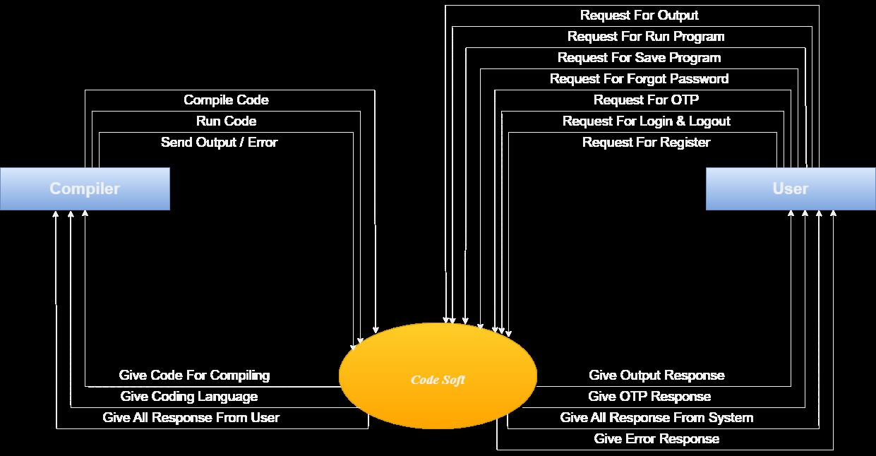

* 1st Level DFD ( User )

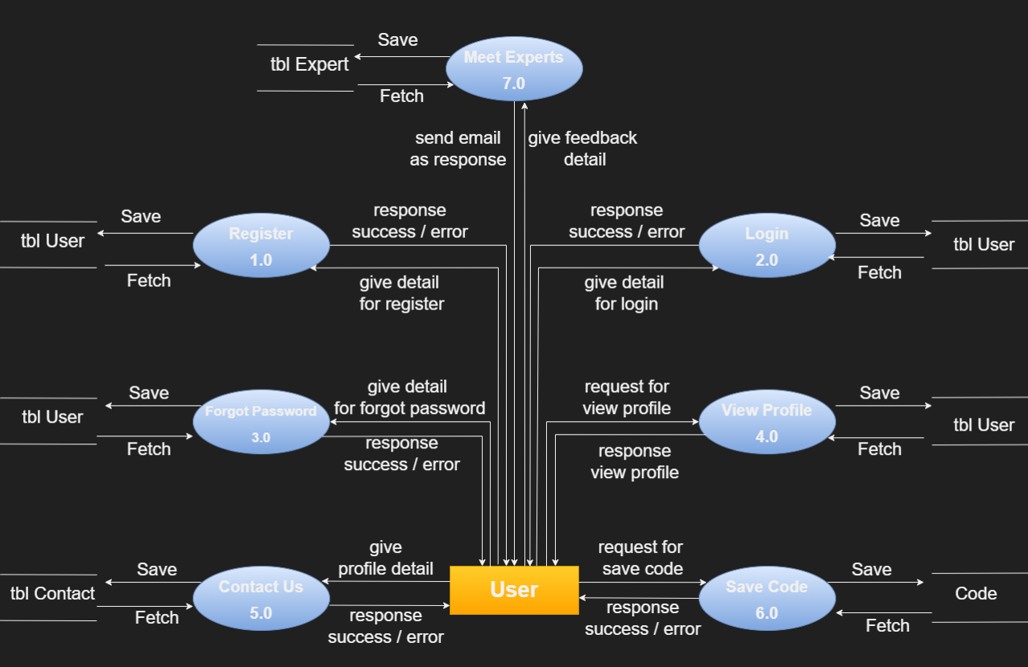

* 1st Level DFD ( Compiler )

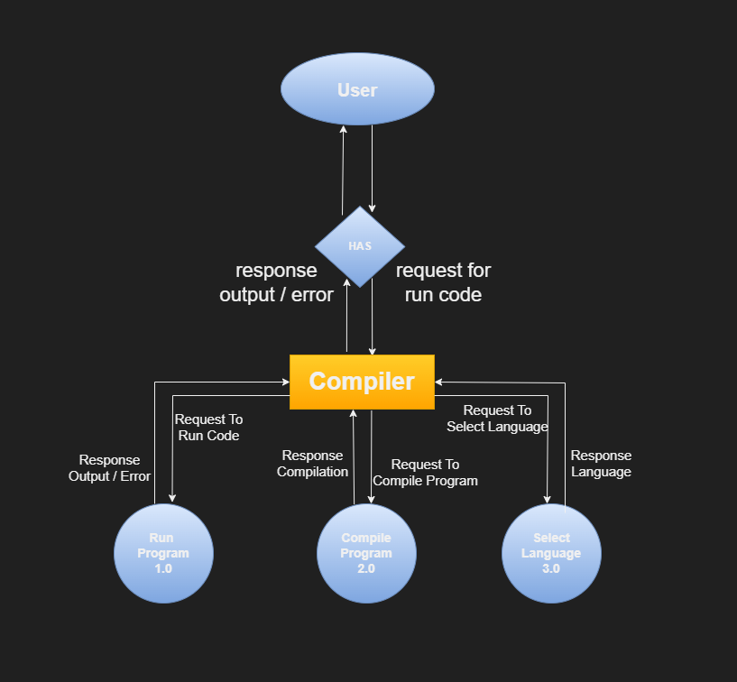

* 2st Level DFD ( User )

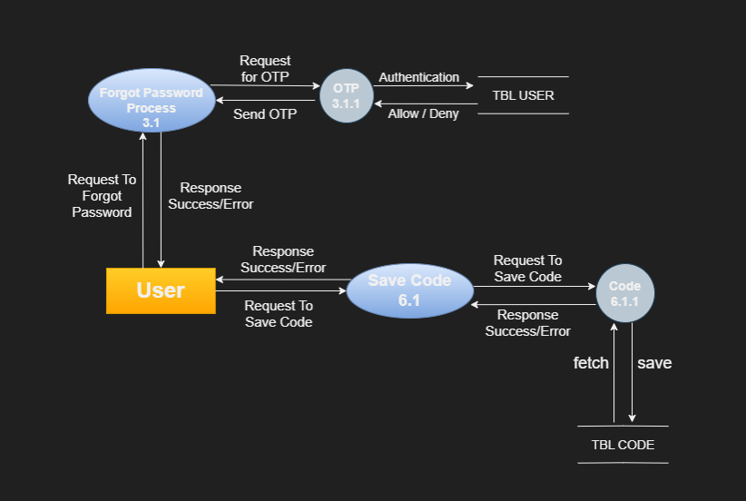

* 2st Level DFD ( Compiler )

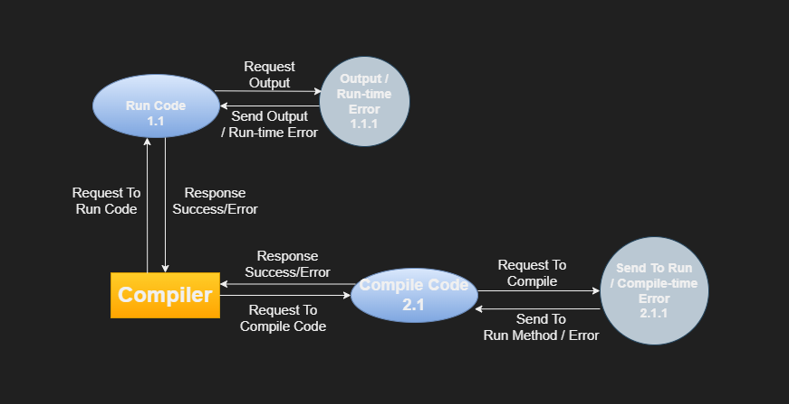

1. **Design Report**

* Frontend Folder Structure :-

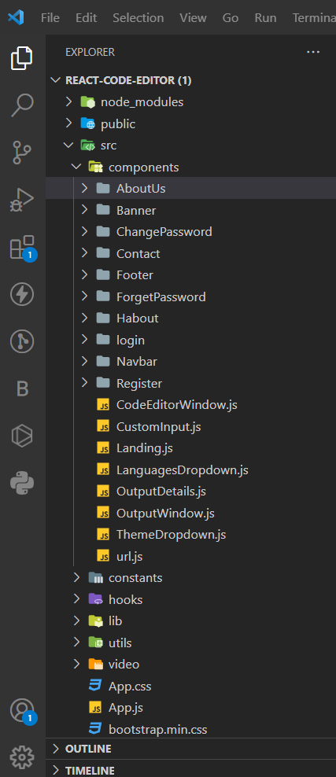

* Backend Folder Structure :-

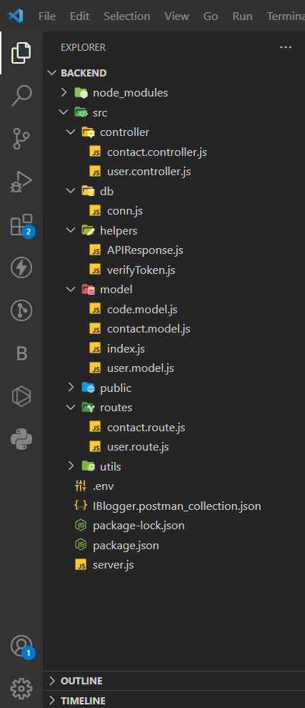

* Home Page :-

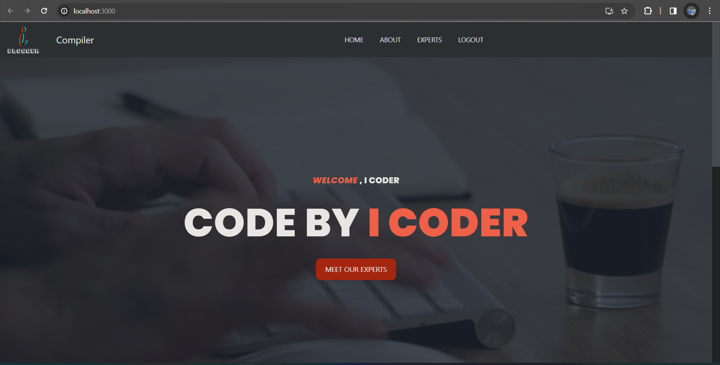

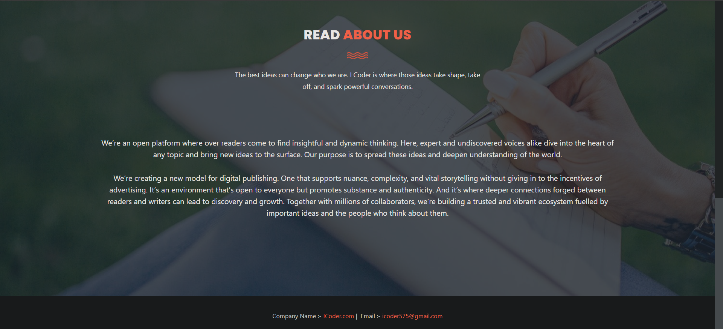

* Login Page :-

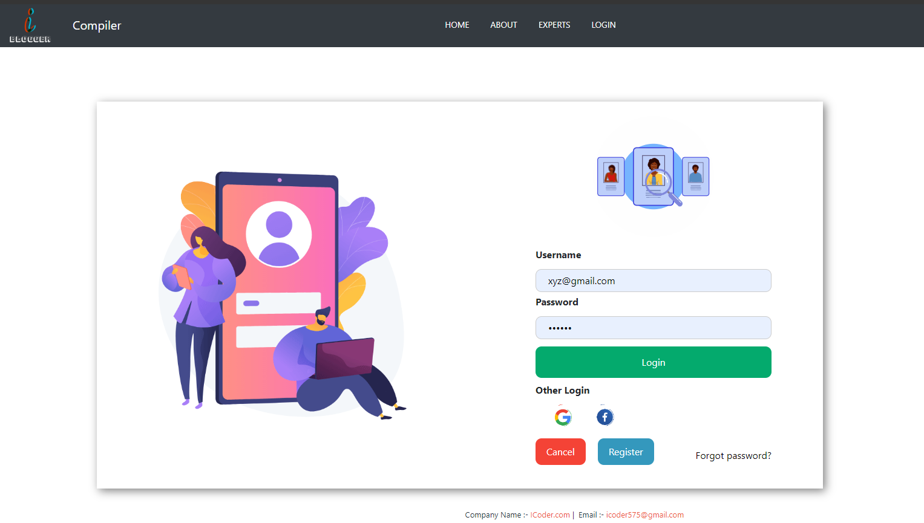

* Register Page :-

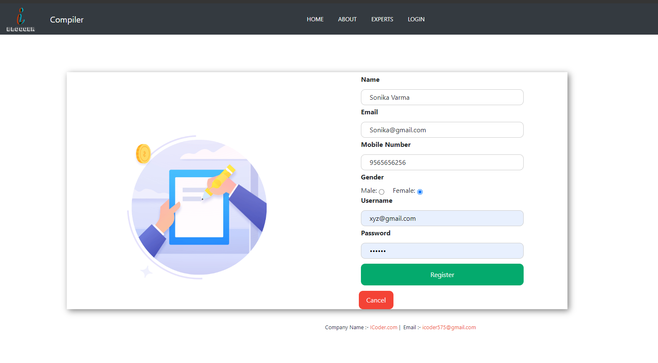

* Forget Password Page :-

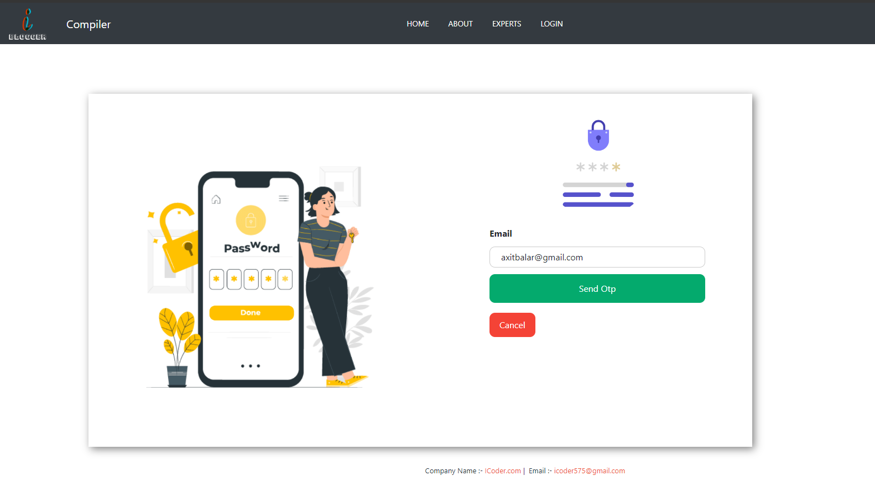

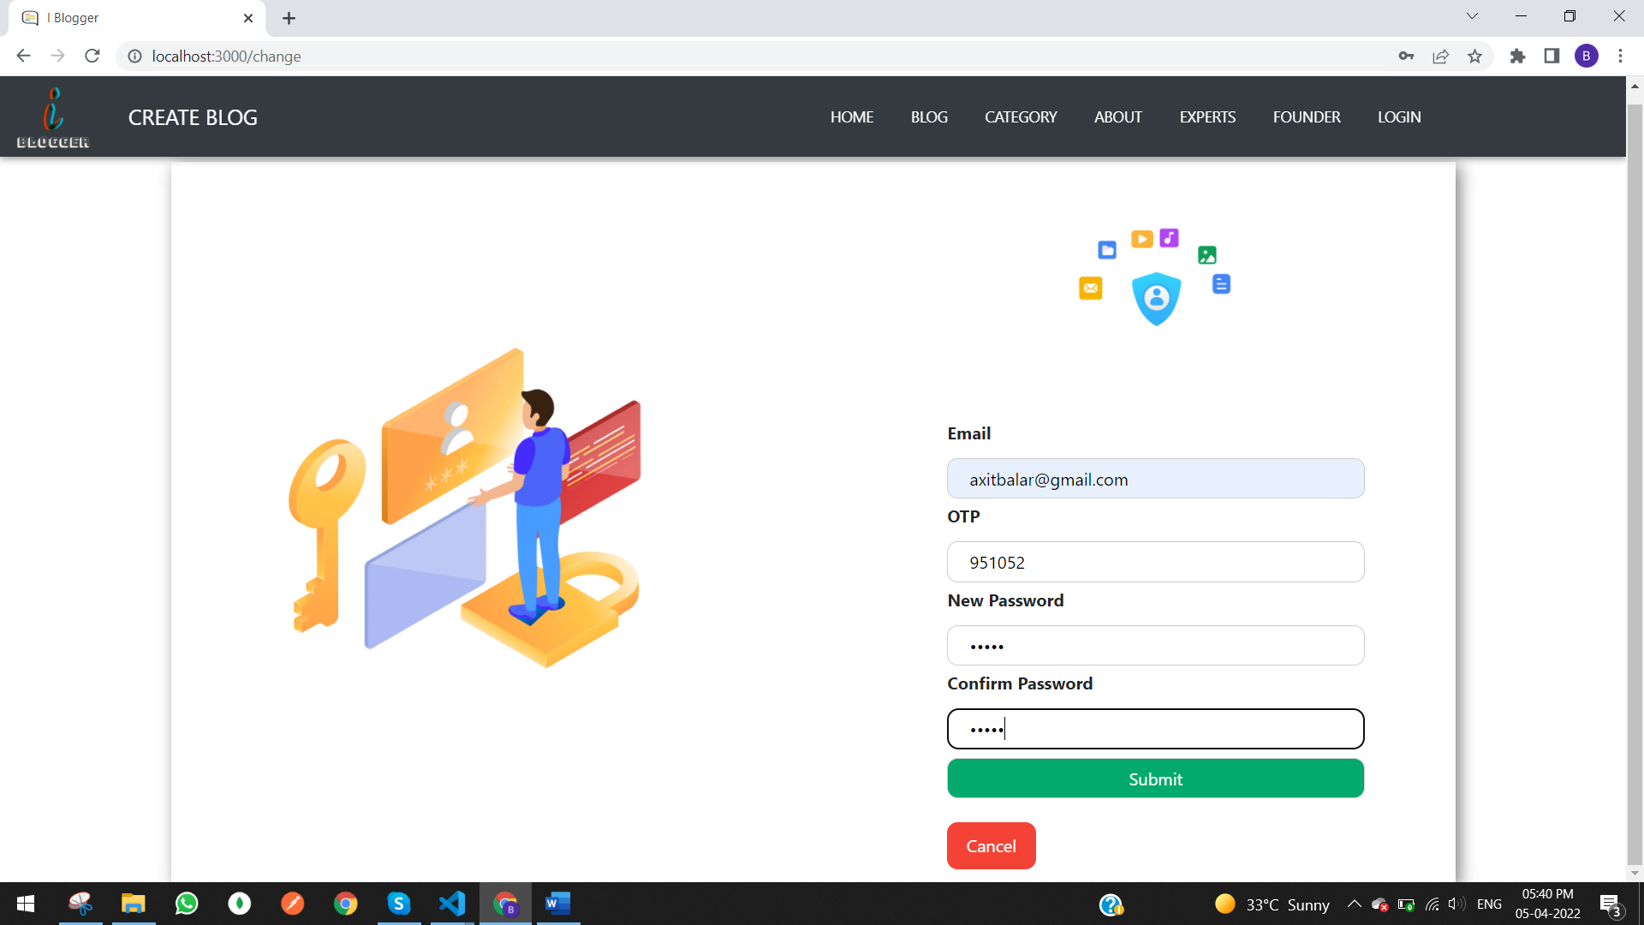

* About Page :-



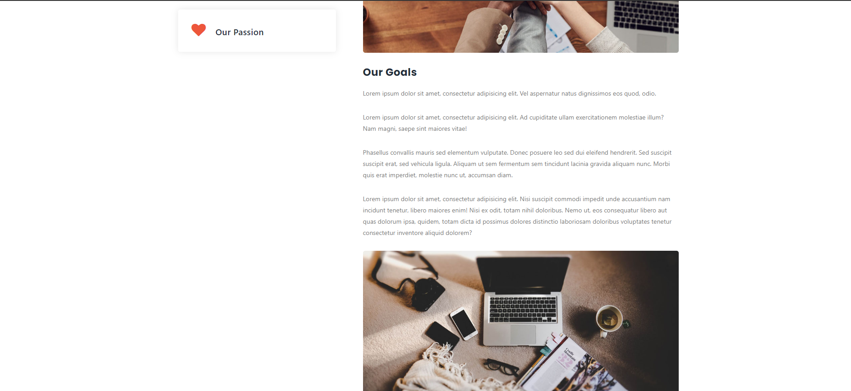

* Contact Us Page :-



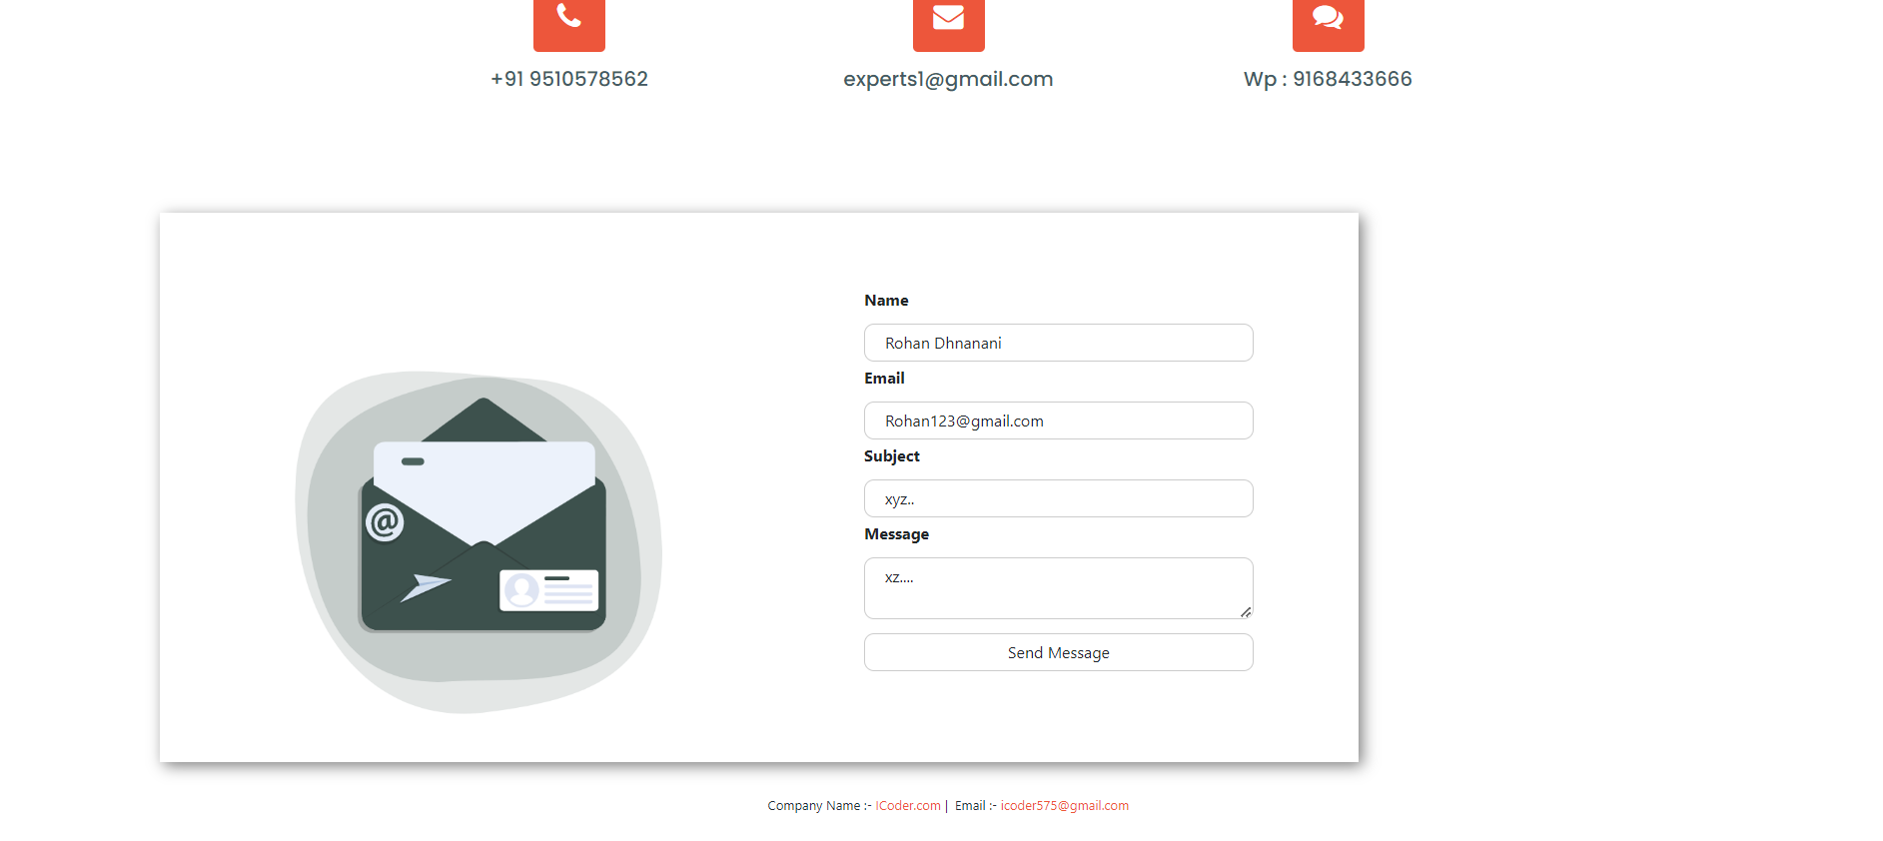

* Compiler Page :-

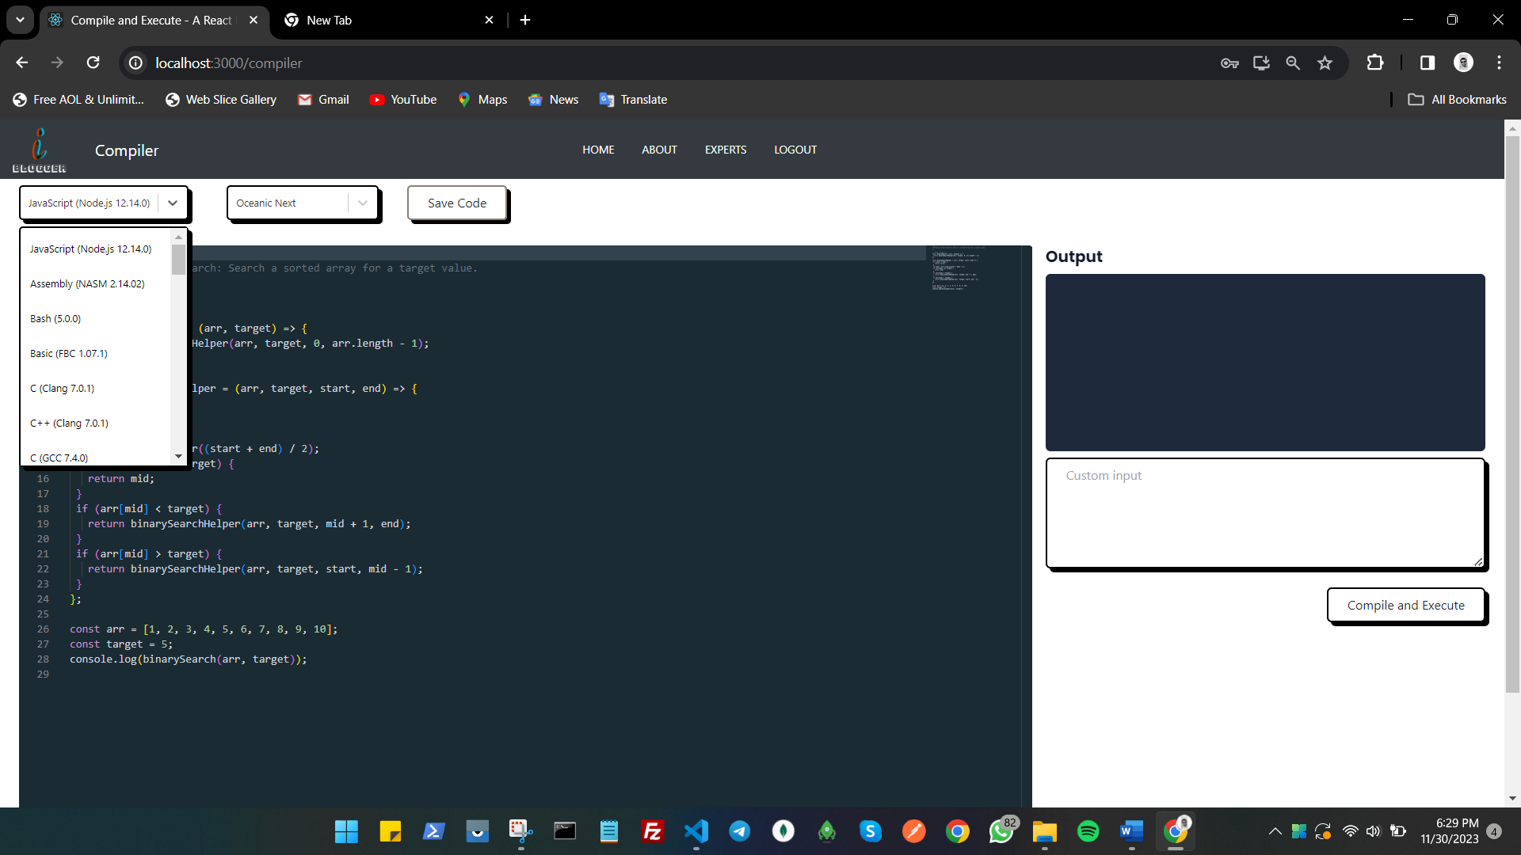

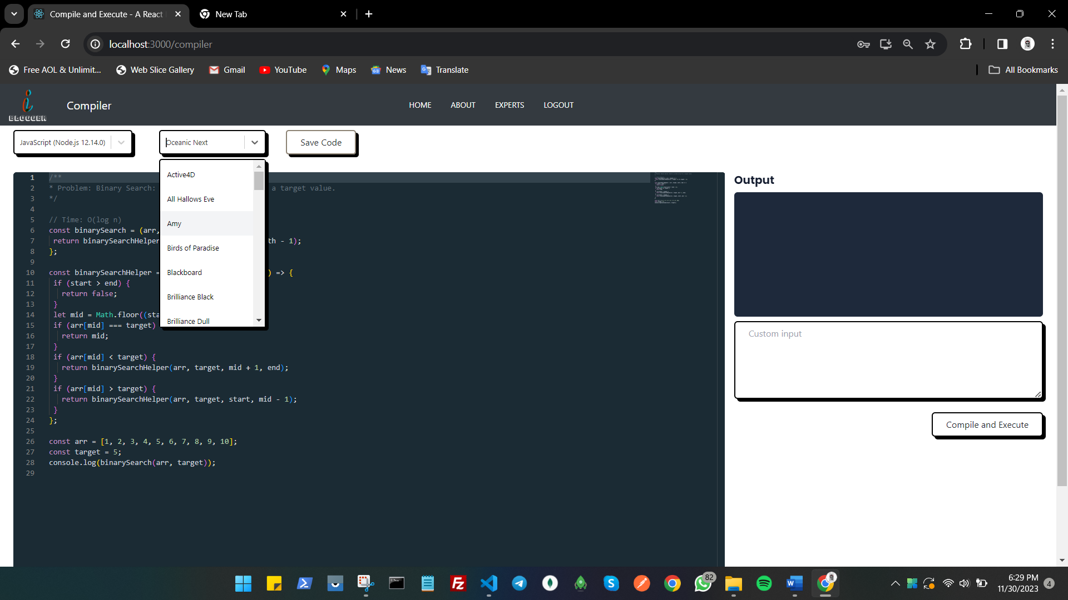

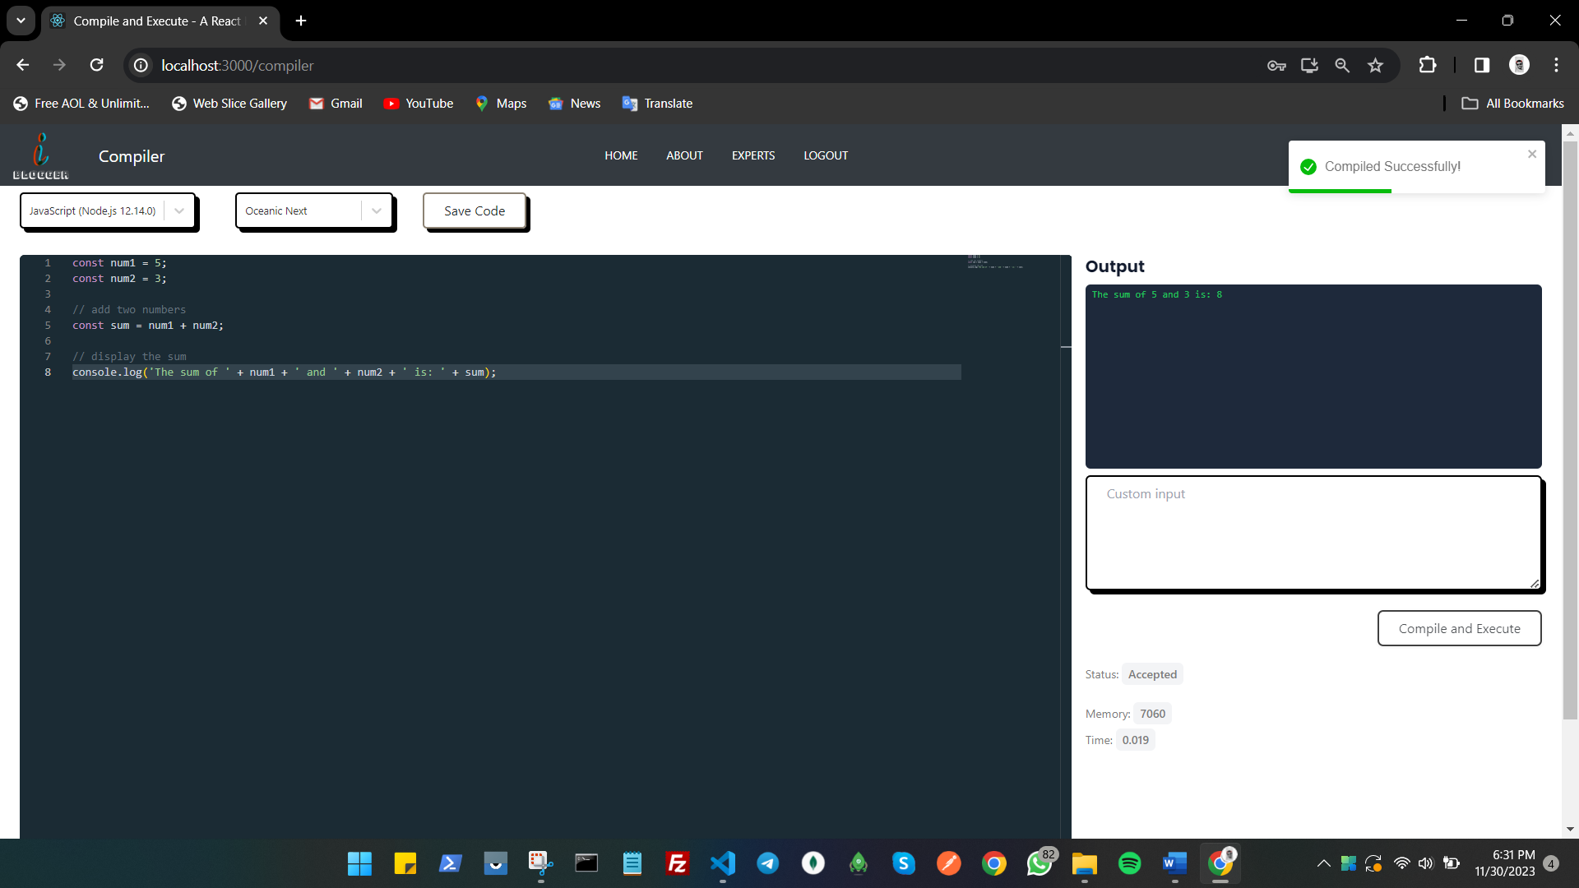

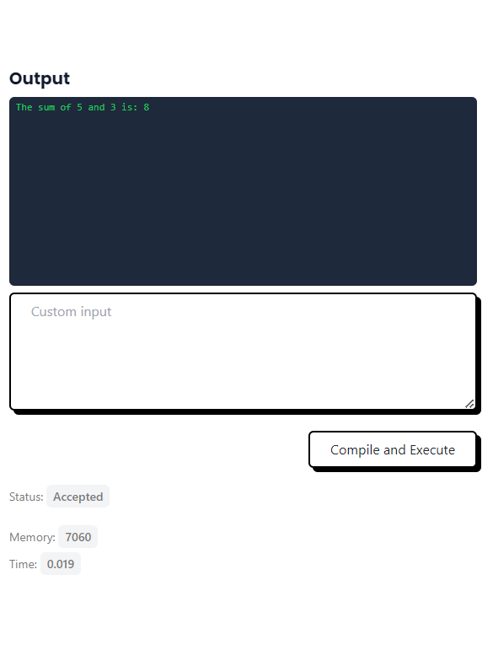

* Save Code Data :-

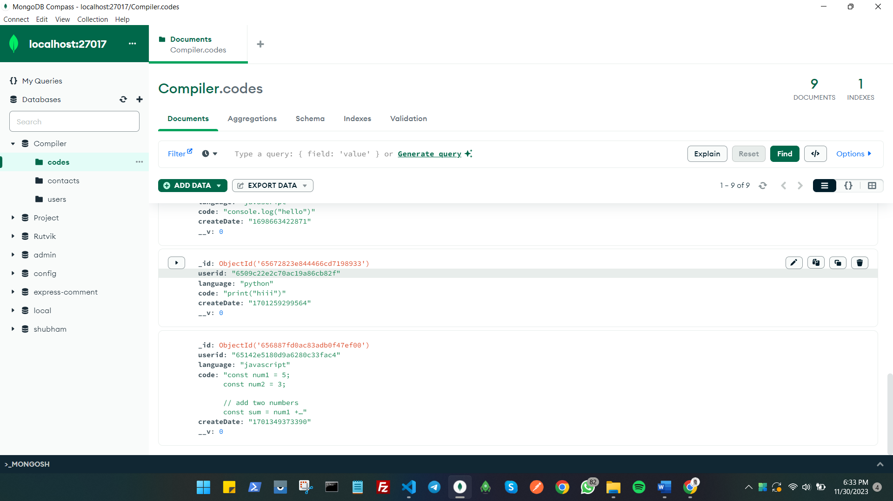

1. **Future Enhancement**

* **Future Enhancement :-**

* We plan to introduce a new page in the future that will allow users to view their saved code.
* We would like to include the ability to see and change profile details in the future, as well as add profile pictures, among other features.
* We plan to use socket.io to add a live room option in the future.
* We also improve the usability of our website.
* We want to provide a share option in the future so users can share their code on other platforms.
* We further improve the durability of our code compilation time.

1. **Conclusion**

* **Conclusion :-**

* We have thoroughly enjoyed working on this fascinating and demanding project. We benefited from this project since it gave us practical experience with Node.js, React.js, and MongoDB.
* The system is efficient and takes less time to set up, having been carefully designed and error-free.
* We learned a lot about a wide range of subjects from this project, including database management with MongoDB and screen design.
* Every part of the system is safe. Additionally, the project improved our knowledge of the web development life cycle and project development phases.
* We are really happy with this project because we created a website that users are able to easily implement in their life.

1. **References**

* **References :-**

<https://www.programiz.com/c-programming/online-compiler/>

<https://www.tutorialspoint.com/compile_c_online.php>

<https://www.codechef.com/ide>

<https://www.online-python.com/online_python_compiler>

* The presentations given by sir and ma’am was a big help for us to complete the project.